Class method

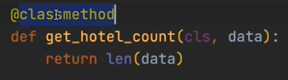

Property

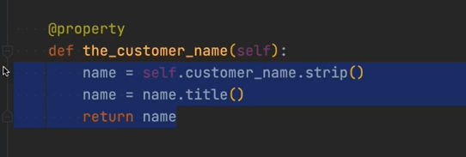

Static method

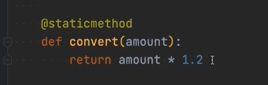

Magic methods

Background happens

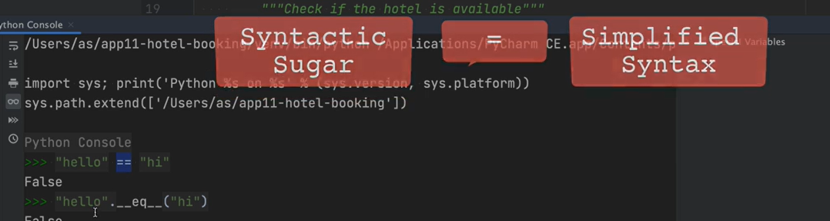

Abstraction

